
- Republic of the Philippines
Laguna State Polytechnic University
Province of Laguna

College of Computer Studies

PROJECT NAME: Cookmate
PROPONENTS: Cariaga, Aisheeya Lizabhelle L.
Canaman, Angiela E.
Carandang, Ayhen Fhayte T.
Coroza, Rosch Vielle C.
YEAR AND SECTION: BSCS 1A

PROJECT OVERVIEW
- Description of the Program
CookMate is a C# console-based recipe application designed to help users choose a dish, view its list of ingredients, check possible alternative ingredients, and follow step-by-step cooking instructions. It serves as a simple digital cooking assistant that provides multiple Filipino and international dishes in an organized and user-friendly format.
The program uses object-oriented programming concepts by creating a Dish class, which stores the name, ingredients, ingredient alternatives, and cooking instructions of each recipe. All dishes are stored inside a list and displayed to the user through the console.
- Explanation of How the Project Works
- The program welcomes the user with a console banner and asks for their name.
- It displays a numbered list of all available dishes (e.g., Bistek, Kare-Kare, Tinola, Spaghetti, etc.).
- The user selects a dish by entering its number.
- The program retrieves that dish from the list and shows:
- The complete ingredients
- Alternative ingredients (if the user chooses to view them)
- Step-by-step cooking instructions
- After the user reviews the recipe, the system displays a “Congratulations” message.

Internally, the system works by:
- Using Lists to store ingredients and steps
- Using a Dictionary to store ingredients with their alternative options
- Using loops, validation, and conditionals to ensure correct user input
- Storing recipes as objects created from the Dish class

- Purpose of the Project
The main purpose of CookMate is to provide an accessible and beginner-friendly tool for learning and cooking different dishes through the console. In addition, CookMate aims to assist users when certain ingredients are not available by providing alternative ingredient suggestions. It allows users to adapt recipes based on what they already have, making cooking more flexible, practical, and convenient. By offering substitutes, the application helps reduce the need for exact ingredients while still enabling users to prepare the selected dish.
It aims to:
- Demonstrate understanding of fundamental programming concepts
- Show proper use of object-oriented programming through custom classes
- Offer a practical application that helps users explore recipes
- Present a structured, clear, and interactive console interface
Overall, CookMate combines learning and functionality by giving users a simple way to select a dish and follow an organized recipe guide.

SYSTEM FEATURES AND FUNCTIONALITIES
1. Dish Selection
- Displays a complete list of dishes with numbers
- Allows the user to choose a recipe by entering the dish number
- Includes input validation to prevent invalid choices

2. Ingredient Display
- Shows all essential ingredients for the chosen dish
- Organized in a clean bullet-point list
3. Alternative Ingredients
- Gives users optional substitutes for each ingredient
- Uses a dictionary to map each ingredient to a list of possible alternatives
- Helps users cook the dish even when certain ingredients are unavailable

4. Step-by-Step Cooking Instructions
- Provides a complete, ordered set of steps
- Uses numbered formatting for clarity
- Ensures the user can follow the process easily
5. User Input Validation
- Ensures dish selection must be a number
- Rejects invalid or out-of-range choices
- Ensures "yes/no" answers are strictly followed
- Prevents crashing or unintended behavior
6. Clean Console User Interface
- Includes ASCII-art title screen
- Uses separators, spacing, and readable formatting
- Clear prompts guide the user step by step
7. Completion Screen
- After reviewing the recipe, the system displays a congratulatory message
- Provides a smooth and friendly experience for the user
- OOP-Based Dish Storage
All recipes are stored as objects with properties (name, ingredients, alternatives, steps), showing understanding of object-oriented programming.
- Recipe Collection
- Contains multiple Filipino and international dishes including:
Bistek, Adobo, Kare-Kare, Sinigang, Tinola, Sisig, Pancit and more
This makes the program feel complete and realistic.
- Ingredient Alternatives System
- A unique feature not usually found in beginner console apps.
- Makes the app more helpful and practical.

SYSTEM DESIGN AND PLANNING
- Flowchart
Figure 1 shows the program flow of CookMate, from dish selection to recipe
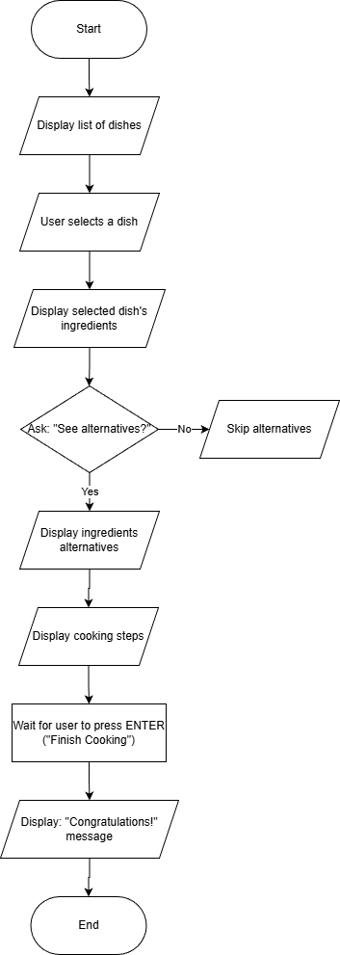
completion.

.

- Pseudocode
START PROGRAM
DEFINE class Dish
Name
Ingredients
IngredientAlternatives
Steps
END CLASS
CREATE list of Dish objects called dishes
ADD multiple Dish entries
Each Dish has:
- Name
- Ingredients
- Ingredient Alternatives
- Cooking Steps
END CREATE
DISPLAY CookMate ASCII logo
DISPLAY welcome message
PROMPT user for name
READ user name
CLEAR screen
DISPLAY "Welcome Chef <name>"
DISPLAY list of available dishes with numbers
REPEAT
PROMPT user to enter dish number
READ input
IF input is not a number
DISPLAY error message
ELSE IF number is out of range
DISPLAY error message
ELSE
ACCEPT input
UNTIL valid dish number is entered
SET selected dish based on user choice
DISPLAY selected dish name
DISPLAY ingredients of selected dish
REPEAT
ASK user if they want to see ingredient alternatives (yes/no)
READ input
IF input is invalid
DISPLAY error message
UNTIL input is valid
IF user chooses YES
DISPLAY ingredient alternatives for each ingredient
END IF
DISPLAY cooking steps in order
PROMPT user to press ENTER when done
WAIT for ENTER
CLEAR screen
DISPLAY congratulations message
DISPLAY thank you message
END PROGRAM
- Description of how logic was structured
The CookMate console application follows a structured and linear logic flow that guides users through every stage of the program. From the initial welcome screen to the final completion message, each section of the code executes in a logical order. This approach improves user interaction, reduces confusion, and ensures that the program remains organized and easy to understand.
A Dish class was created to store all recipe-related data, including the dish name, ingredients, substitutes, and cooking steps, in one location. A list is utilized to hold all dish objects, allowing the program to manage many recipes simultaneously and making it easy to add new dishes. The application starts by displaying a welcome screen and asking for the user’s name to personalize the experience. Next, it shows a numbered list of available dishes. The user input is validated to ensure only correct dish numbers are accepted. Once a dish is selected, the program displays the ingredients and asks if the user wants to see alternative ingredients. If the user agrees, the substitutes are presented in an organized manner. Finally, the cooking steps are displayed in order, guiding the user through the recipe. At the end of the program, a completion message is shown, providing a clear and friendly conclusion.

PROGRAM STRUCTURE AND CORE CONCEPTS APPLIED
- Variables and Data Types
In this program, variables are used to store information that the app needs while running, such as the user’s name, the selected dish, ingredients, and cooking steps. Strings are used for text, integers are used for numbering and choices, and lists are used to store multiple items like ingredients. This makes the program organized and able to change based on the user’s input.
- Operators
Operators are used to make the program work correctly. They help assign values, compare user input, and combine text for display. For example, the program checks if the number entered by the user is valid and adjusts the numbering so it matches the menu. These operators help control how the program responds to the user.

- Selection Structures (if/else, switch)
The program uses if-else statements to decide what should happen next. If the user enters an invalid dish number or types an incorrect response, the program shows an error message and asks again. This prevents the program from crashing and helps guide the user to give the correct input.
- Looping Structures
Loops are used so the program can repeat tasks easily. The program uses loops to display the list of dishes, ingredients, and cooking steps. A while loop is also used to keep asking the user for input until a valid answer is given. This makes the program interactive and user-friendly.
- Arrays
Instead of using basic arrays, the program uses lists and dictionaries to store data. Lists are used for dishes, ingredients, and steps, while dictionaries store alternative ingredients. This makes the data easier to manage and allows new dishes to be added without changing the main code.
- Methods (user-defined functions)
The Dish class is used to group all the information related to one dish, such as its name, ingredients, alternatives, and steps. Although most of the program logic is executed within the Main method, the use of a dedicated Dish class demonstrates proper object-oriented structure and prepares the system for future modularization.
Overall Program Flow - The program starts by greeting the user and asking for their name. It then shows a list of dishes, lets the user choose one, and displays the ingredients and cooking steps. After the user finishes cooking, the program ends with a congratulatory message. Overall, CookMate is designed to be simple, helpful, and easy to understand.

SCREENSHOTS OF PROGRAM OUTPUT
Menu
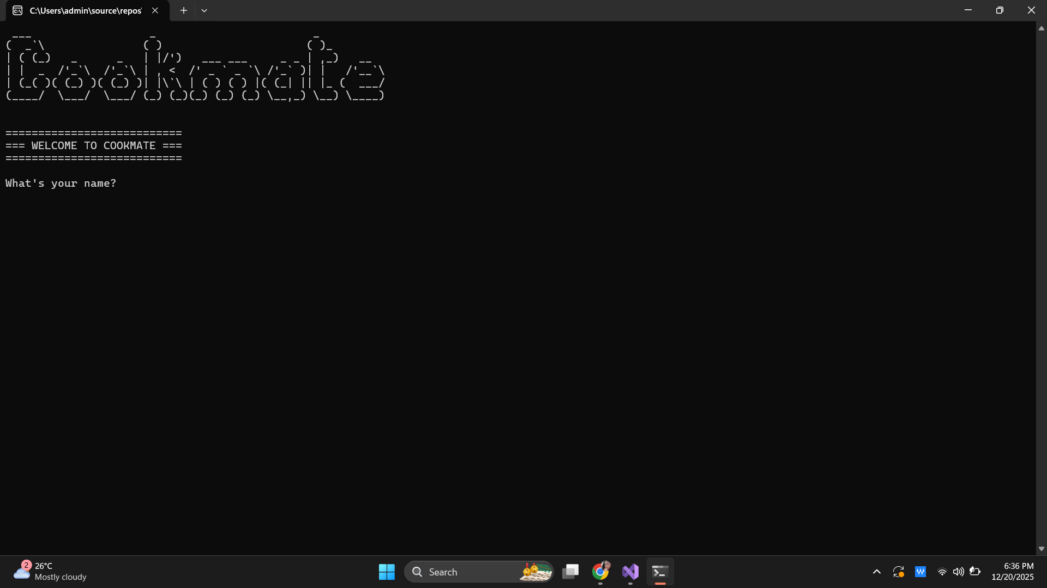
List of Dishes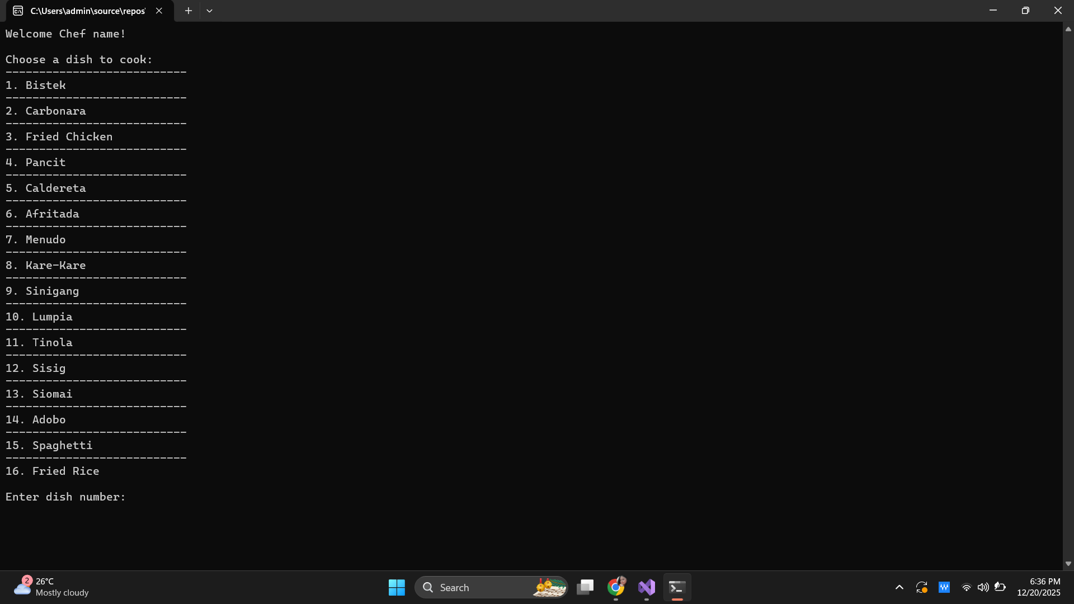
Input of letters instead of valid number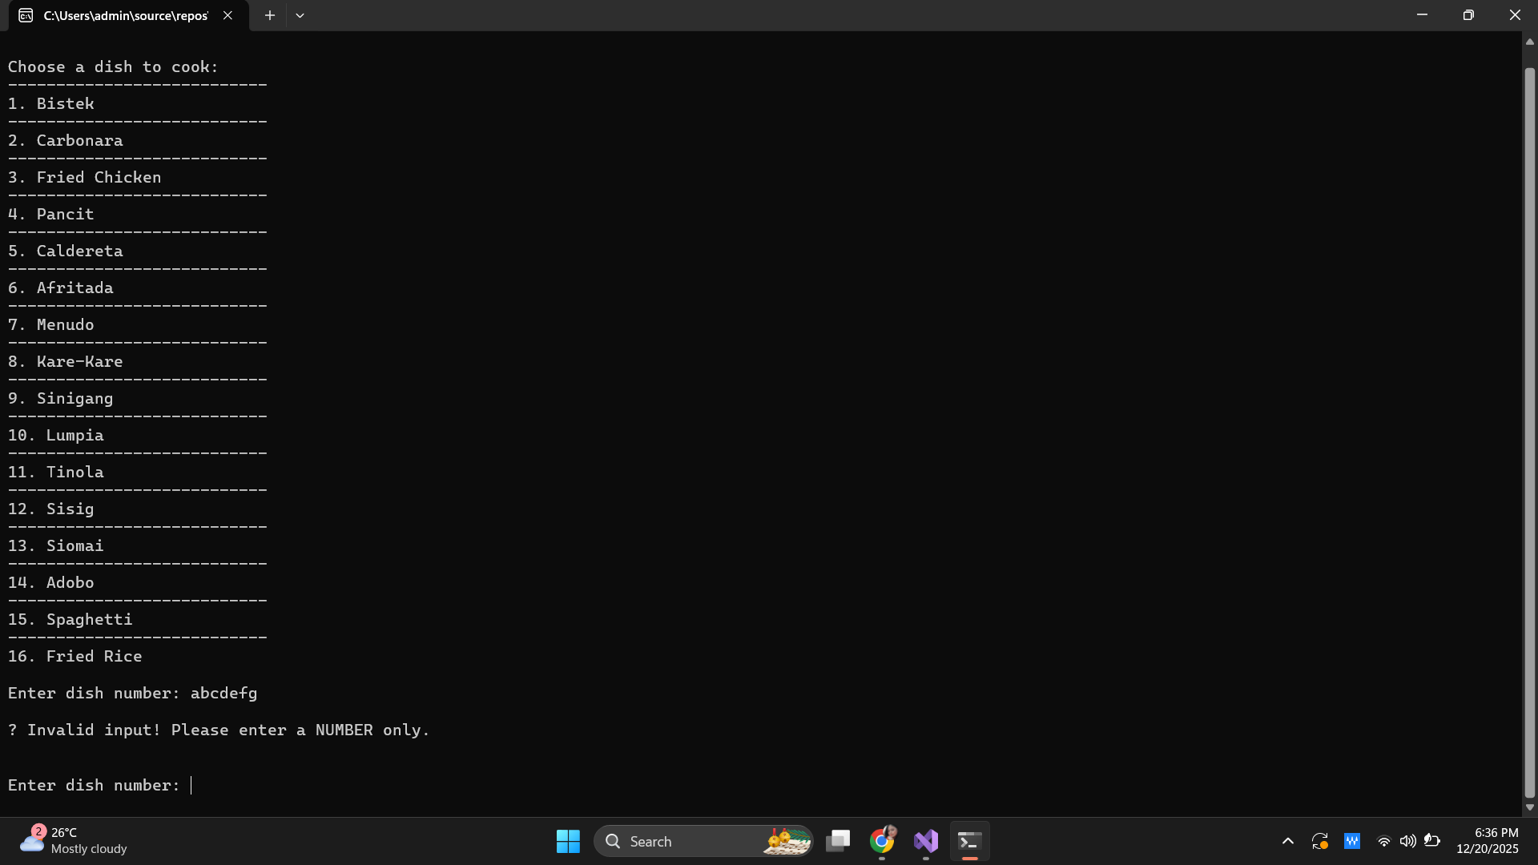
Input of a number that is out-of-range
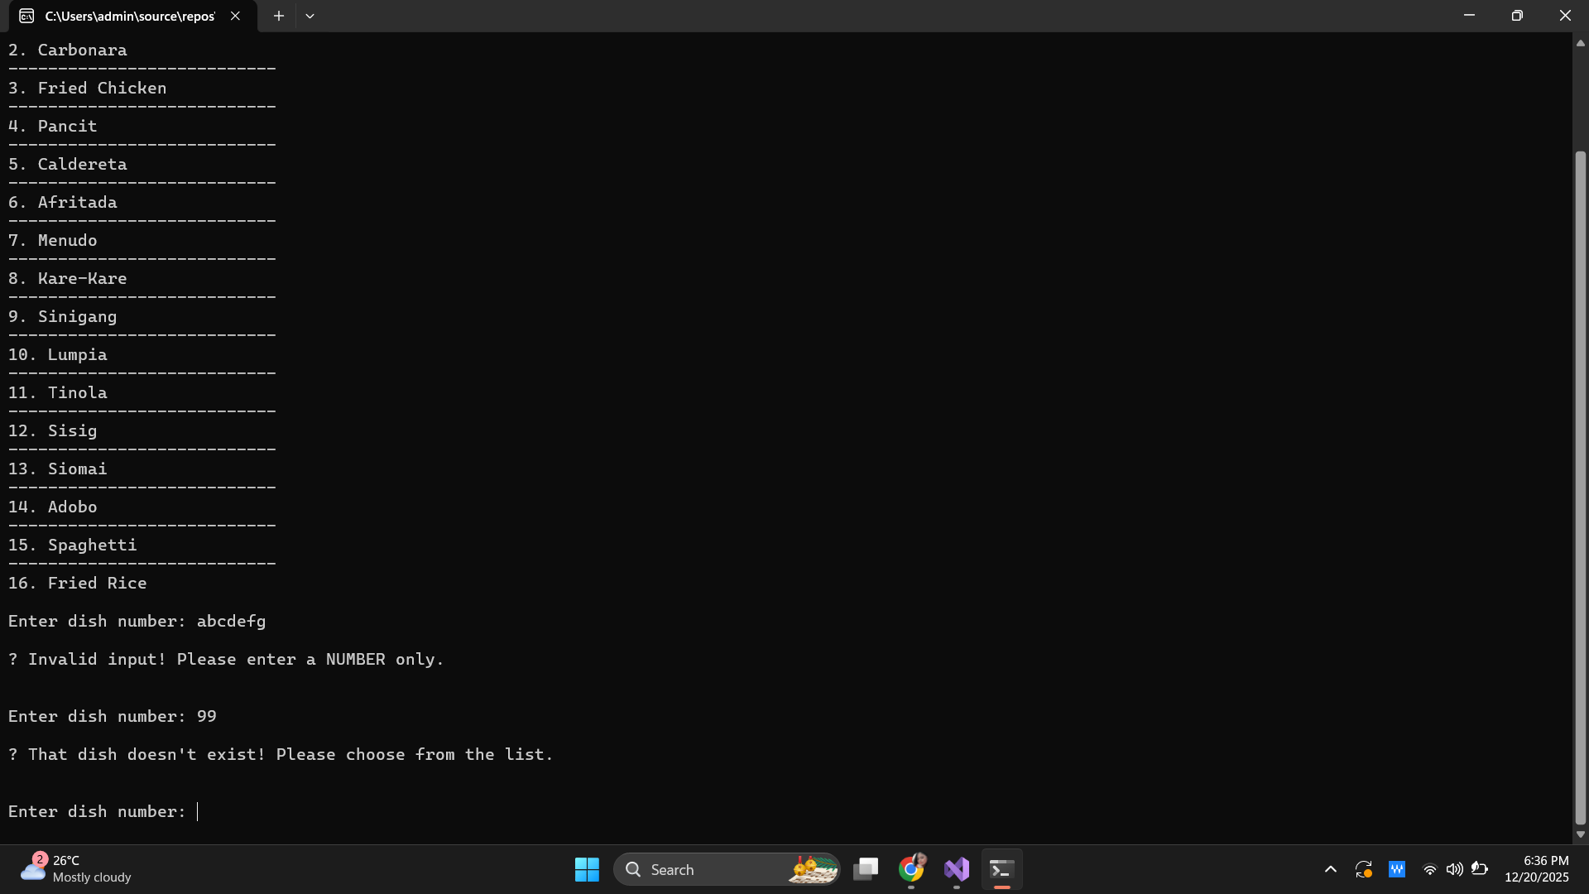

List of Ingredients
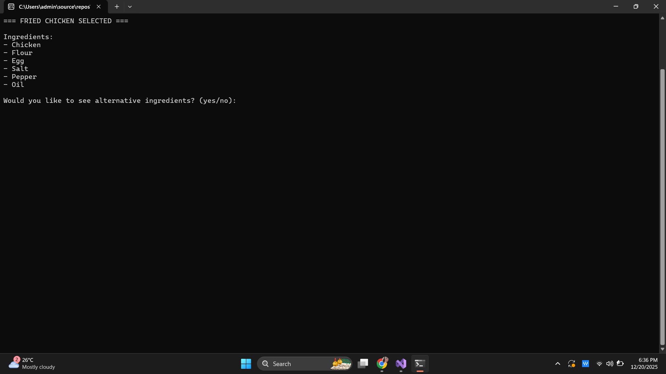
Invalid inputs of answer
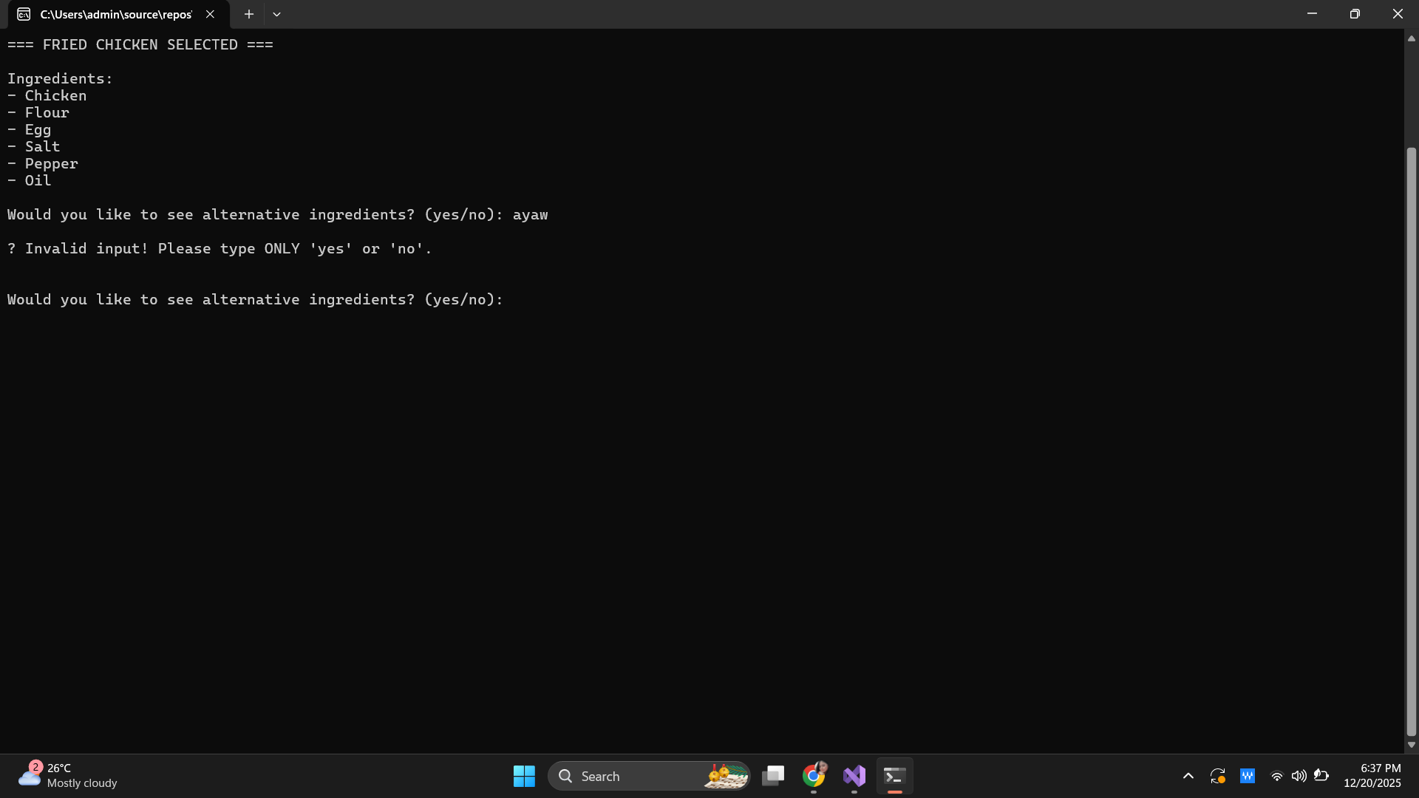
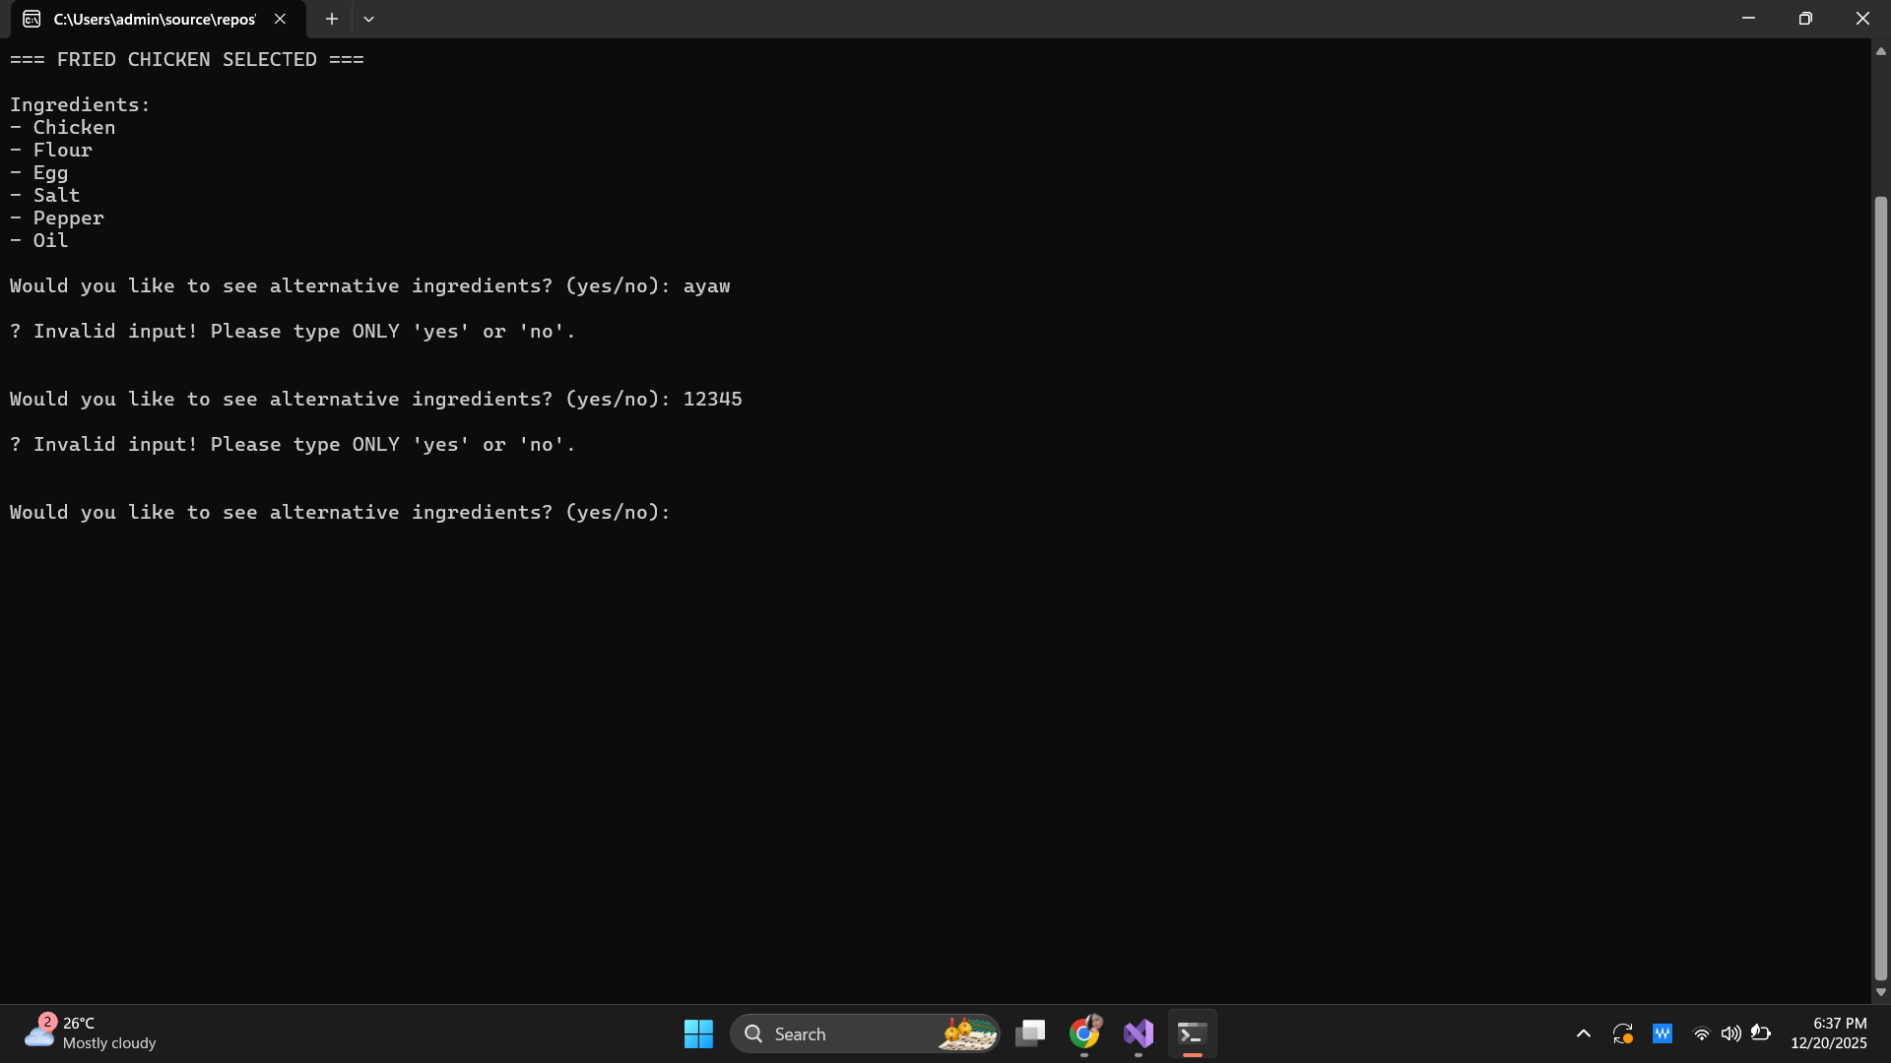
List of alternative ingredients and cooking instructions
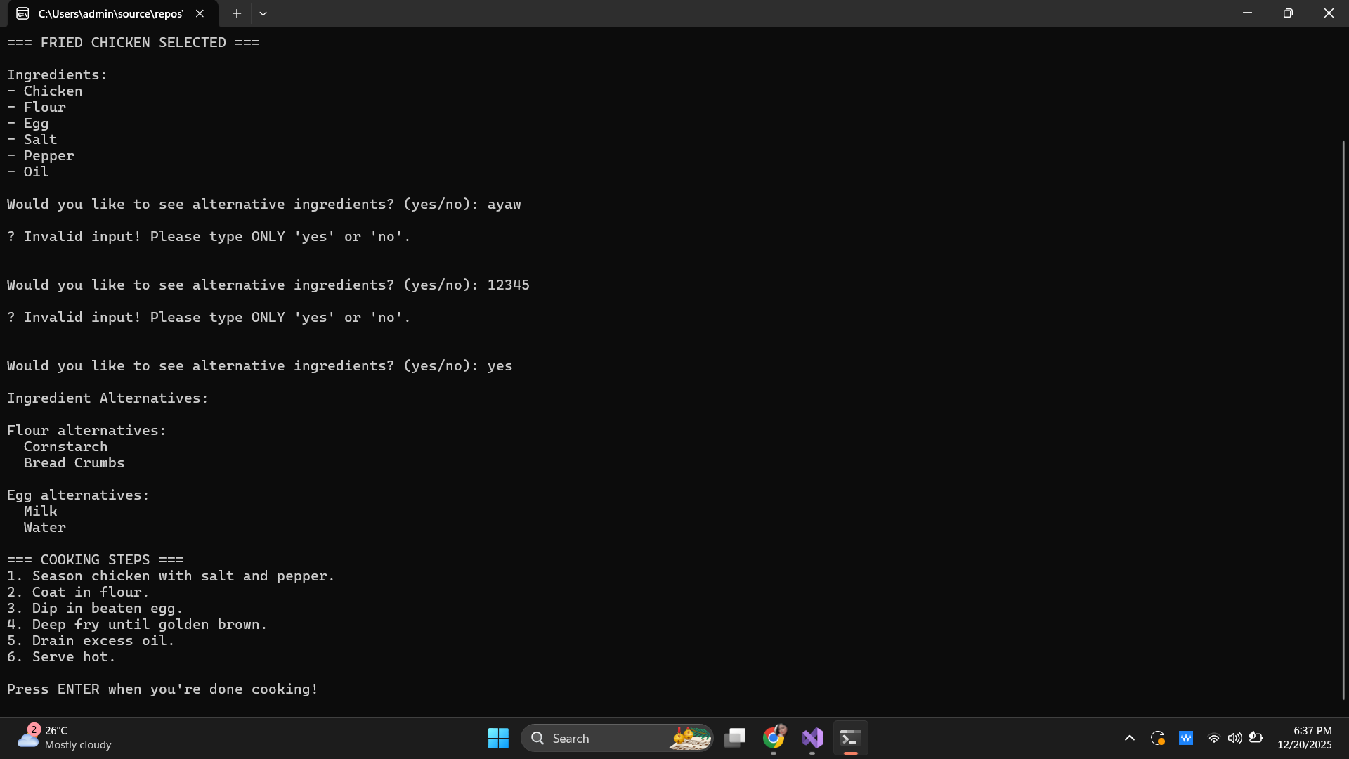
Congratulatory message/End screen
CONCLUSION
- Learnings from the development
The project served as a reminder of the necessity of planning in advance of coding, as pseudocode creation and programming flow outlining facilitated the organization of logic, issue prediction, and hence, reduced significant rewrites. It also emphasized the real-life object-oriented programming skills of the usage of classes, lists, and dictionaries particularly to deal with complex data conveniently and efficiently. The processing of user input brought about the necessity for careful validation which was the only way to ensure reliability, avoid crashes, and at the same time, writing of code that was easy to read, and maintainable thus, debugging became easier. Testing and the increment of development were stricken off the errors, thus, problem-solving and debugging skills were refined. Furthermore, having the user in mind while designing—even without a graphical interface—made the usability better through prompts, instructions, and feedback that were clear. At last, the program's architecture for scalability showed how well-organized code could accommodate future growth, for example, adding new recipes or features that would not affect the core logic.
- Challenges experienced and how they were solved
CookMate, being a console-based application, relies entirely on text input, which can lead to problems if users enter unexpected values. For example, users might type letters, symbols, or words instead of numbers when selecting a dish, or respond with anything other than “yes” or “no” when asked about ingredient alternatives. Without proper handling, these inputs could cause errors, crashes, or unpredictable behavior. To address this, input validation was implemented using loops and conditional statements, ensuring the program only proceeds with valid input. If an invalid value is entered, an error message is displayed and the user is prompted again, improving both stability and user experience.
Another challenge is the limited number of dishes initially available in CookMate, which can reduce its usefulness and replay value. To make the program scalable, a Dish class was used, with all recipes stored in a list. This allows new dishes to be added easily by creating new objects and adding them to the list, making future expansion straightforward.
Additionally, the program currently does not account for different dietary preferences, such as allergies, vegetarian, vegan, or low-sodium requirements. Implementing filters or tags for recipes and expanding alternative ingredients to include dietary substitutions could make the application more inclusive and user-friendly.
Finally, because the program runs in a console environment, it lacks visual feedback, which could confuse users about how to navigate or interact with the application. To overcome this, the program was designed with clear prompts, step-by-step instructions, friendly messages, and confirmation steps. A welcoming introduction sets the tone, guiding users through selecting dishes, viewing ingredients, and following cooking instructions, making the application easy to use even for those with limited technical experience.
- Possible improvement or future features
Future improvements for CookMate could greatly enhance its usability and functionality. A search and filter feature would allow users to quickly find recipes based on ingredients they have at home, preferred cuisine types, dietary restrictions, or cooking methods like baking, frying, or boiling, making recipe selection faster and more personalized. Adding difficulty levels and estimated cooking times would help users choose dishes that match their cooking skills and available time, reducing trial-and-error and improving the overall cooking experience. The ability to save favorite recipes would allow users to quickly access dishes they enjoy the most, while providing nutrition information, such as calories, protein, fat, and carbohydrate content, could support users who are health-conscious or following specific diets. Expanding the application with multi-language support would make CookMate accessible to a broader audience, breaking language barriers and attracting other users. Finally, meal planning and weekly menus could transform CookMate into a full-featured cooking assistant, enabling users to plan meals ahead, organize recipes by day, and streamline grocery shopping, making it more than just a recipe viewer.

REFERENCES (if any)
- Learn Live - Create and run simple C# console applications
https://www.youtube.com/watch?time_continue=3696&v=8NEcTdkw_dw&embeds_referring_euri=https%3A%2F%2Fwww.google.com%2Fsearch%3Fq%3Dhow%2Bto%2Bmake%2Bcooking%2Bapp%2Busing%2Bconsole%2Bc%2523%26sca_esv%3D5346d96e928e7d71%26sxsrf%3DAE3TifMTvf-SewleOLZcPz&source_ve_path=MjM4NTE
- The Dictionary Data Structure in C3 in 10 minutes or less
https://www.youtube.com/watch?v=R94JHIXdTk0

